**Key Success Factors for Startups: A Topic Modeling Analysis of the Social Media and Digital Marketing Era** (1500 words)

**Research Question:** How have the key factors determining startup success evolved with the rise of social media and digital marketing?

**Background:**

In today’s rapidly evolving business environment, social media and digital advertising have become critical for startup growth and success. A few years ago, businesses relied on traditional channels like TV ads and newspapers to reach their audience, which often lacked the precision and real-time engagement offered by today’s platforms. Social media has transformed advertising into a highly targeted, data-driven process, enabling startups to reach specific demographics, interact directly with consumers, and adjust strategies on the fly. Notable studies such as (Kenedi, 2023) identified key success factors in pioneering digital startups. (José, 2019) established which issues affect the ecosystem of startups in India and to identify what users feel about those issues which could be used by investors to acquire information and help their decision-making strategies when investing in Indian startups. Studies have shown that understanding these shifts and their impact on startup success is essential for navigating the future of business and marketing. This study will explore how these changes in advertising and sentiment have shaped the current business landscape and influenced the success factors of modern startups.

**Data:**

Reddit is an excellent platform for collecting data on startup success because it hosts a wide variety of discussions from diverse communities. Reddit users often engage in open and detailed discussions about their experiences, challenges, and strategies for startup growth, making it a valuable source for real-world opinions.

The dataset I will be collecting consists of posts from relevant subreddits. To ensure relevance, I will use both keyword searches ("successful startup factors") and regex patterns to filter posts containing phrases such as r”startup\s+success\s+factor",

        r"factors\s+for\s+startup\s+growth",

        r"predictors\s+of\s+startup\s+success",

        r"keys?\s+to\s+successful\s+ecommerce?",

        r"startup\s+(growth|scalability|traction)\s+factors",

        r"market\s+fit\s+for\s+startups?",

        r"funding\s+strategies\s+for\s+startups",

        r"customer\s+acquisition\s+for\s+startups",

        r"team\s+dynamics\s+in\s+startups?",

        r"entrepreneurial\s+(skills|traits)\s+for\s+startup\s+success"

**Key Aspects of the Dataset:**

1. **Subreddits**: Data will be collected from the following:
   * **r/smallbusiness**
   * **r/Entrepreneur**
   * **r/startup**
   * **r/social media marketing**
2. **Search Query**: The search will use queries " successful startup factors "(131 posts),’’What are the key success factors for a startup business?”(52 posts),” key successful startup factors during social media era”(74 posts), "factors influencing startup success"(34 posts),” strategies for a successful business in digital era”(53 posts),”qualities of a successful startup”(134 posts),”social media marketing tips for successful startup”(86 posts)
3. **Timeframe**: Data will be collected for a specific time range, between 2019-2023, to capture recent discussions when covid kicked off the digital marketing era.
4. **Post Content**:
   * **Post title**
   * **Post Body**
   * **Post upvotes**

**Methodology:**

**1. Data Collection**

We collected data from Reddit using the `PRAW` (Python Reddit API Wrapper) library. Our focus was on subreddits relevant to startups and entrepreneurship. To target discussions around startup success factors, we conducted multiple queries as mentioned above. These queries were chosen to capture a wide range of posts discussing various success factors in startups, particularly during the social media era. Each post's metadata, including the title, body, upvotes was stored for further analysis. To ensure relevance to recent discussions on startup success, we filtered posts from the time period between January 2019 and December 2023.

**2. Data Preprocessing**

Data preprocessing was performed to prepare the text data for analysis and ensure consistency across the dataset. Key steps included:

- URLs, special characters and numbers were removed from the post content to reduce noise.

- Tokenization and Lemmatization: The text was tokenized into individual words, and each word was lemmatized to its root form. This standardization step ensured consistency in word usage across the dataset.

- Stopword Removal: Common stopwords (e.g., “the,” “is,” “and”) and custom stopwords (eg 'look', 'good', 'want', 'need', 'know', 'like', 'really', 'think', 'thing', 'stuff') were also removed. Only the tokens containing nouns, verbs and adjectives were kept.

- TF-IDF Vectorization: A Term Frequency-Inverse Document Frequency (TF-IDF) matrix was generated to represent the importance of words in each post. TF-IDF allowed us to prioritize words that are frequent in individual posts but rare across the corpus. This is essential to topic extraction from a large data corpus.

The preprocessed data was stored in a new column named `Processed_Text` within the dataset.

**3. Topic Modeling Using Latent Dirichlet Allocation (LDA)**

We applied Latent Dirichlet Allocation (LDA), a probabilistic topic modeling technique, to identify key topics within the dataset. LDA helped uncover common themes by grouping words that frequently co-occur in similar contexts. The steps involved in the LDA analysis were as follows:

- The `Processed_Text` data was vectorized into a Document-Term Matrix using TF-IDF values, where each row represented a document (post), and each column represented a term.

- After testing, we selected five topics to provide a broad but manageable set of themes related to startup success factors.

- We applied the LDA algorithm to the DTM, setting a maximum of 10 iterations to achieve convergence. Each topic was represented by a set of words and their corresponding probabilities, which indicated the weight of each word within that topic.

- Topic Interpretation: The top words for each topic were examined to label the topics manually.

The LDA model was visualized using pyLDAvis, an interactive visualization tool, to explore the relationships between topics and terms.

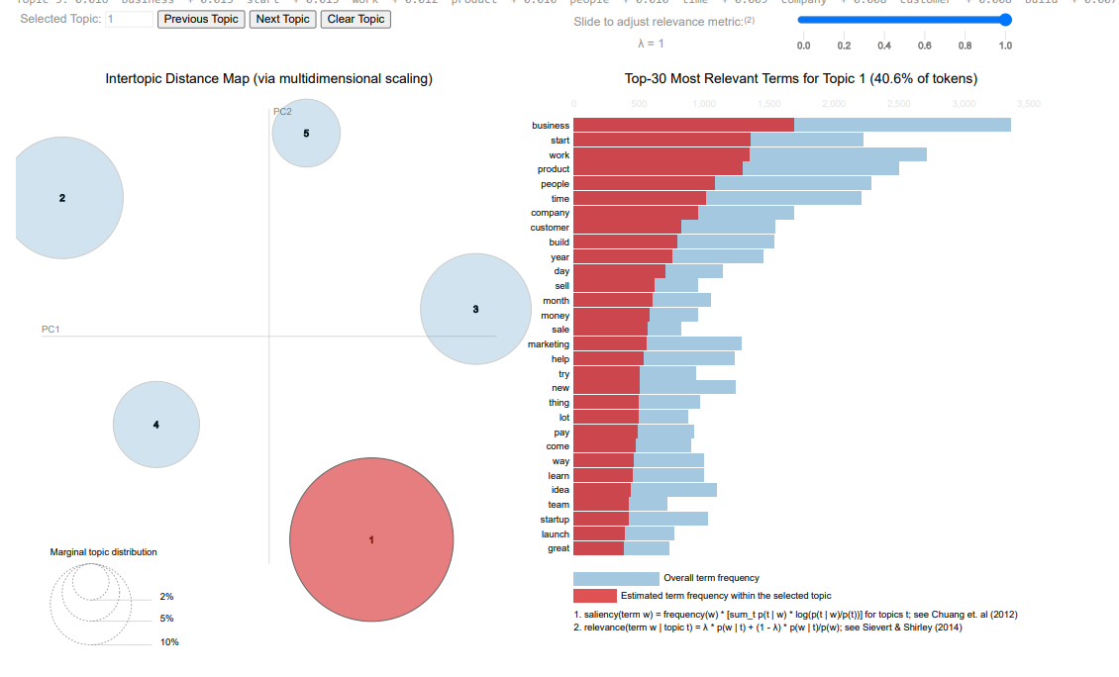

**Figure 1: Intertopic Distance Map and Top-30 Most Relevant Terms for Topic 1 in LDA Model**

**4. Extraction of Top-Rated Words**

After generating the LDA topics, we extracted the highest-rated words across all topics based on their weights. This list of top words represented the most significant terms within our identified topics. We ranked words in descending order based on their relevance scores and selected the highest-rated terms as key factors in startup success.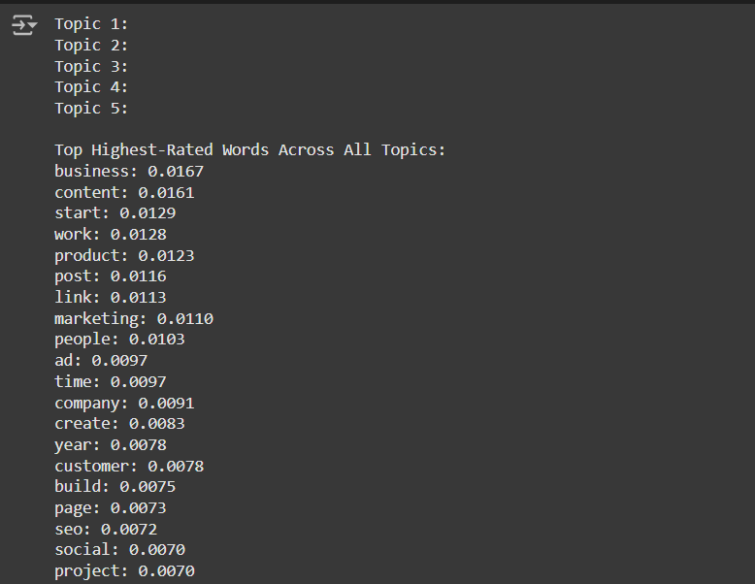

**Figure 2 Top 20 highest rated words across all topics in the data corpus**

**5. Contextual Analysis of Highest-Rated Words**

To gain deeper insights into how each top word was used in posts, we performed a contextual analysis. For each word in the list of top words, we retrieved sentences or snippets from the `Processed_Text` column where the word appeared. This involved:

- Keyword-in-Context (KWIC) Analysis: For each occurrence of a top word, a window of 50 characters before and after the word was extracted to capture surrounding context.

- Unique contexts were extracted for each word within each document to reduce redundancy and capture diverse ways in which the term was discussed.

- We stored each word, its context, and the document index in a structured format in a new Data Frame

The extracted contexts were saved to a CSV file for further qualitative analysis, enabling us to study the nuances of each word within the context of startup discussions.

The combined results were presented as:

- Top-Rated Words and Contexts: A list of top-rated words alongside their surrounding contexts, showing factors critical to startup success.

- LDA Topics: Visualized topic clusters via pyLDAvis to illustrate the main themes across the dataset.

**Results**

|  |  |  |
| --- | --- | --- |
| **Topic Word** | **Sample Contexts** | **Most likely factor** |
| **ad** | |  | | --- | | * customer matter people tell scalable need use pay ad Seo scalable way acquire customer great work work | | * ng stay flexible iterate fast eye product website ad adapt base performance stick endless meeting rega | | **Customer acquisition and promotional strategies.** |
| **build** | |  | | --- | | * nt job bad realize capable want job spend weekend build demo hope knock sock send mind race busy hire bus | | * dit work level work year plan try figure weakness build tell key factor successful entrepreneur possess y | | **Building skills or processes within the startup.** |
| **business** | |  | | --- | | * customer experience textmagic marketing software business enable easy text message marketing monthly subscr | | * user innovative approach simplify billing process business seek improve customer engagement translatepress s | | * instream clear pricing structure start year cater business look early insight success story showcase diversi | | **Core aspects of business operations** |
| **company** | |  | | --- | | * screw life drop respectable job degree money feel company family feel coworker good friend show work mornin | | * ole loud success hear bunch people build exciting company people care team family customer ignore entrepren | | **Non toxic and growth driven company environment** |
| **content** | |  | | --- | | * edium platform user save time increase efficiency content creator personal brand digital marketer subscript | | * rship source code earn proof repurposeio automate content distribution repurposeio simplifie task reposte c | | **Content creation and time efficiency.** |
| **create** | |  | | --- | | * on hype fury tweet scheduling hype fury microsaas create cofounder solve problem scheduling twitter thread | | * uality one walk door leave future product stumble create sell customer ask referral referral kick right pe | | up mission travel affordable lot traveler service create new market travel industry exciting advice start | | **Creating hype or digital presence** |
| **customer** | |  | | --- | | * el make affordable attractive textmagic transform customer experience textmagic marketing software business | | * ch simplify billing process business seek improve customer engagement translatepress simplify website transl | | **Quality of Customer service and process improvements** |
| **link** | |  | | --- | | * ad recommendation answer question ask doable here link try read rest get month build service sure time t | | * mobile phone initial vision want audio clickable link website clickable music tv show movie sort vision | | **Networking and online visibility.** |
| **marketing** | |  | | --- | | * nerate month recur revenue tool simplifie twitter marketing help user grow monetize twitter audience list gui | | * keting software business enable easy text message marketing monthly subscription use prepay credit offering f | | **Digital marketing strategies and tools.** |
| **page** | |  | | --- | | * energy building iterate multiple version api doc page try open source solution api documentation time c | | * time engineer build maintain api doc page api doc page page english word code snippet different programm | | * t programming language user able run code example page require design repeatable process automatic manua | | **Media visibility and building interactive webpages** |
| **product** | |  | | --- | | * table month customer get momentum customer matter people tell scalable need use pay ad seo scalable way ac | | * success hear bunch people build exciting company people care team family customer ignore entrepreneur med | | **Quality and usefulness of product in the market** |
| **post** | |  | | --- | | * lesson recur revenue reddit write post blog think find interesting happy answer question | | * hood help right month post decline k job employer post promise update guy lot happen son bear bask prese | | **Social media interaction** |
| **people** | |  | | --- | | * lance solitary want work change ego threaten year people tell travel great degree job place work hate idea | | * ce hard advice traction feel choose niche exclude people come door reality choose email marketing professi | | * table month customer get momentum customer matter people tell scalable need use pay ad seo scalable way ac | | **Team dynamics** |
| **project** | |  | | --- | | * eal need center focus year decide convertkit move project project decision convertkit today brag business r | | * center focus year decide convertkit move project project decision convertkit today brag business run cring | | * aft commerce moment week month push deadline trim project scope reprioritize backlog hope go live demo foll | | **Project planning and innovation.** |
| **seo** | |  | | --- | | * y seo service personal injury lawyer stat product seo personal injury lawyer revenuemo start location c | | * e use bundle benefit hr resource payroll umbrella seo tool ahref semrush agency analytic scream frog to | | * irm seo niche specialize personal injury law firm seo decision gross revenue come personal injury clien | | **Search engine optimization for visibility.** |
| **Social** | |  | | --- | | * bution repurposeio simplifie task reposte content social medium platform user save time increase efficienc | | * increase trust product performance marketing pay social sea affiliate create continuous customer lead vie | | * e hard tell purchase amazon customer find website social channel search amazon free prime shipping new cus | | **Social media management** |
| **start** | |  | | --- | | * y hire web designer find ask interested move role start study free time thank interested artist coder pee | | * nth kyear double salary believe come easy amazing start strapped rocket allstar team grow change world fa | | * rised understand day css basic graphic design day start learn javascript wait switch lane learn like end | | **Foundational steps** |
| **time** | |  | | --- | | * m interested new startup subscribe thank valuable time | | * reposte content social medium platform user save time increase efficiency content creator personal bran | | **Time management** |
| **work** | |  | | --- | | * productivity write code formula rewrite research work great window resell cost ownership source code ea | | * gage fee freelance go work month work live saving work want job freelance solitary want work change ego | | * ade experience amateur comparison earn spot great work value celebrate team try recall memory doubt proo | | **Productivity and work processeses** |
| **year** | |  | | --- | | * tzky moment start apply lot reject lot demoralize year carefree adventure unemployable month rejection d | | * meet call sense reach hire thank tip look senior year experience ping miss shot realize time lbs little | | * freelance solitary want work change ego threaten year people tell travel great degree job place work ha | | **Long term planning** |

**Table 1 Depicting Sample contexts of top words from each topic and an interpretation for each factor**

**Conclusion**

The analysis of Reddit discussions on startup success has highlighted several critical factors that founders and business professionals consider essential in the digital and social media era. By applying topic modeling through LDA and examining the contexts in which key terms appear, we identified core themes that resonate with contemporary startup strategies. These factors reflect a blend of traditional business fundamentals and modern digital approaches, providing a holistic view of what contributes to a startup’s success in today’s market.

**Key factors identified:**

1. **Business Development and Foundations**: A significant focus in online discussions is on the foundational aspects of a business, including planning, team building, and the initial processes of creating a startup. Effective management of these early stages is seen as crucial for long-term sustainability.

2. **Product Development and Customer Focus:** Building a product that meets customer needs remains at the heart of successful startups. The iterative process of understanding customer preferences, gathering feedback, and refining the product was frequently mentioned as an essential factor for growth.

3. **Sales and Revenue Generation**: Generating revenue and achieving profitability are central to startup discussions, with emphasis on effective pricing, sales strategies, and overall financial health. Terms like "sell," "money," and "marketing" reveal the importance of establishing clear revenue paths from the start.

4. **Digital Marketing and Online Presence**: In the modern digital landscape, having a strong online presence is non-negotiable. Strategies around content creation, SEO, and social media management were highlighted as crucial for attracting and engaging customers. These discussions indicate that effective digital marketing is now one of the primary ways to achieve visibility and credibility in competitive markets.

5. **Time and Resource Management**: Efficient management of time and resources emerged as another core theme. Entrepreneurs frequently discussed strategies for prioritizing tasks, setting goals, and maximizing productivity, all of which contribute to smoother operations and sustainable growth.

6. **Financial Planning and Funding**: Securing adequate funding and managing finances prudently were consistently identified as critical success factors. The importance of financial planning and funding acquisition for growth and stability reflects a traditional, yet still essential, pillar of startup success.

7. **Adaptability and Continuous Learning**: Adaptability, resilience, and continuous learning are key traits for successful founders, allowing them to navigate challenges, innovate, and adjust based on feedback.

This study shows that while core business principles like product development, customer focus, and financial management remain essential, digital marketing, social media, and online tools have reshaped how startups achieve these goals. Success today requires not only strong fundamentals but also a robust digital presence, resource efficiency, and adaptability. These findings highlight the importance of blending traditional business strategies with modern digital practices, offering a roadmap for entrepreneurs navigating the complexities of today’s startup environment. This research enhances our understanding of contemporary success factors and provides a foundation for further study on the impact of digital strategies in entrepreneurship.

**References:**

Saura, J.R.; Palos-Sanchez, P.; Grilo, A. Detecting Indicators for Startup Business Success: Sentiment Analysis Using Text Data Mining. *Sustainability* 2019, *11*, 917. <https://doi.org/10.3390/su11030917>

Saura, J.R.; Reyes-Menéndez, A.; deMatos, N.; Correia, M.B. Identifying Startups Business Opportunities from UGC on Twitter Chatting: An Exploratory Analysis. *J. Theor. Appl. Electron. Commer. Res.* **2021**, *16*, 1929-1944. <https://doi.org/10.3390/jtaer16060108>

BINOWO, K., & HIDAYANTO, A. N. (2023). Discovering success factors in the pioneering stage of a digital startup. *Organizacija*, *56*(1), 3–17. https://doi.org/10.2478/orga-2023-0001